**MODULE: 1 (SDLC)**

1. **What is Software? What is Software Engineering?**

**Definition of Software**

* Software is a set of instruction or set of programs are known as a Software.
* It is part of computer, which can’t be touched.
* Software tells a computer what to do and how to do it.

**Definition of Software Engineering**

* Software engineering is a systematic approach to the design, development, operation and maintenance of software system.
* It is the art of developing quality software on time and within budget.

1. **Explain Types of Software.**

* **System S/W**
* System S/W is providing platform to other Software.
* It is control and manage the operation of computer hardware.
* Is the s/w used by computer to translate inputs from various source into a language which a machine can understand.
* Ex. Window, Android, iOS, Linux, macOS
* **Application S/W**
* The s/w that help your computer program for performing user tasks it’s called Application s/w.
* **Types of application s/w**

1. **Mobile Application.**

* App. That run on mobile.
* Ex. FB, Instagram etc.

1. **Desktop Application.**

* That run stand-alone in desktop or laptop computer.
* Ex. MS office suite which includes Word, Excel and PowerPoint.
* Ex. Outlook for email, Firefox, google chrome are the web browser.

1. **Web Application**

* That run on a web browser
* Ex. Google.com, facebook.com etc.
* **Programming s/w**
* Programming s/w is process of designing, writing, testing, debugging, and maintaining the source code of computer programs.
* This s/w is written in programming language.
* Ex. Html, C++, java, php, python etc.

1. **What is SDLC? Explain each phase of SDLC.**

**Definition of SDLC**

* A software life cycle model is a pictorial and diagrammatic representation of the software life cycle.
* A life cycle model represents all the methods required to make a software product transit through its life cycle stages.
* A SDLC is essentially a series of steps, or phases, that  
  provide a model for the development and lifecycle management of an application or piece of software.

**The Phase of SDLC are as follows:**

* **Planning and requirement analysis**
* During this phase, all the relevant information is collected from the customer to develop a product as per their expectation. Any ambiguities must be resolved in this phase only.
* Business analyst and Project Manager set up a meeting with the customer to gather all the information like what the customer wants to build, who will be the end-user, what is the purpose of the product. Before building a product a core understanding or knowledge of the product is very important.
* Planning for the quality assurance requirements and identifications of the risks associated with the projects is also done at this stage.
* Once the required function is done, an analysis is complete with auditing the feasibility of the growth of a product. In case of any ambiguity, a signal is set up for further discussion.
* Once the requirement is understood, the Software Requirement Specification document is created. The developers should thoroughly follow this document and also should be reviewed by the customer for future reference.
* **Analysis Phase**
* This phase starts with the requirement document delivered by the requirement phase.
* The analysis phase defines the requirements of the system, independent of how these Requirements will be accomplished.
* This phase defines the problem that the customer is trying to solve.
* The deliverable result at the end of this phase is a requirement document.
* Ideally, this document states in a clear and precise fashion what is to be built.
* This analysis represents the ―what” phase.
* The requirement documentaries to capture the requirements from the customer's perspective by defining goals.
* **Design Phase**
* The next phase is about to bring down all the knowledge of requirements, analysis, and design of the software project.
* Design Product Document.
* Implementation Plan
* Critical Priority Analysis
* Performance Analysis
* Test Plan
* The Design team can now expand upon the information established in the requirement Document.
* The requirement document must guide this decision process.
* **Implementation Phase**
* In this phase of SDLC, the actual development begins, and the programming is built.
* The implementation of design begins concerning writing code.
* Developers have to follow the coding guidelines described by their management and programming tools like compilers, interpreters, debuggers, etc. are used to develop and implement the code.
* The implementation phase deals with issues of quality, performance, baselines, libraries, and debugging.
* The end deliverable is the product itself. There are already many established techniques associated with implementation.
* **Testing Phase**
* After the code is generated, it is tested against the requirements to make sure that the products are solving the needs addressed and gathered during the requirements stage.
* The testing phase is a separate phase which is performed by a different team after the implementation is completed.
* During this stage, unit testing, integration testing, system testing, acceptance testing is done.
* **Deployment**
* Once the software is certified, and no bugs or errors are stated, then it is deployed.
* Then based on the assessment, the software may be released as it is or with suggested enhancement in the object segment.
* After the software is deployed, then its maintenance begins.
* **Maintenance Phase**
* Once when the client starts using the developed systems, then the real issues come up and requirements to be solved from time to time.
* This procedure where the care is taken for the developed product is known as maintenance.

1. **What is DFD? Create a DFD diagram on Flipkart.**

**Definition of DFD**

* A Data Flow Diagram is a traditional visual representation of the information flows within a system.
* A neat and clear DFD can depict the right amount of the system requirement graphically.
* It can be manual, automated, or a combination of both.
* It shows how data enters and leaves the system, what changes the information, and where data is stored.
* The objective of a DFD is to show the scope and boundaries of a system as a whole.
* It may be used as a communication tool between a system analyst and any person who plays a part in the order that acts as a starting point for redesigning a system.
* The DFD is also called as a data flow graph or bubble chart.

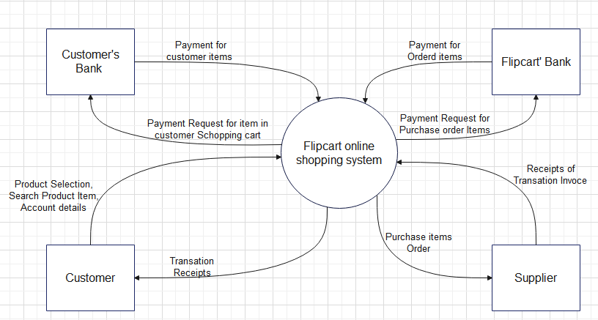**DFD diagram on Flipkart Level-0**

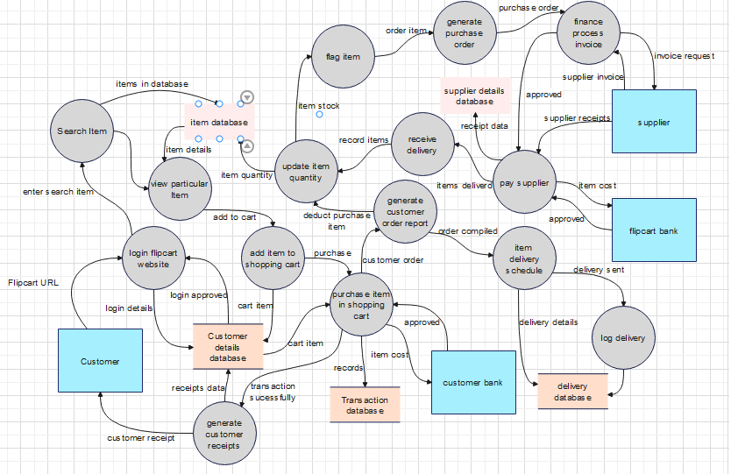**DFD diagram on Flipkart Level-1**

1. **What is Flow chart? Create a flowchart to make addition of two numbers.**

**Definition of Flowchart**

* The Flowchart is the most widely used graphical representation of an algorithm and procedural design workflows.
* It uses various symbols to show the operations and decisions to be followed in a program. It flows in sequential order.

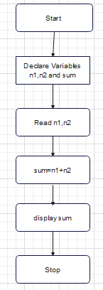

1. **What is Use case Diagram? Create a use-case on bill payment on Paytm.**

**Definition of Use case Diagram**

* A use case diagram is used to represent the dynamic behavior of a system.
* It encapsulates the system's functionality by incorporating use cases, actors, and their relationships.
* It models the tasks, services, and functions required by a system/subsystem of an application.
* It depicts the high-level functionality of a system and also tells how the user handles a system.

